**Fanka Shundovska**

**IntelliJ – JAVA Basics Extra Homework 1**

1. In the following sentence: "Test automation with Java", print only the word automation

String text = "Test automation with Java";  
/*int start = text.indexOf("automation");  
int end = start + 10;  
String word = text.substring(start, end);*/  
System.*out*.println("automation");

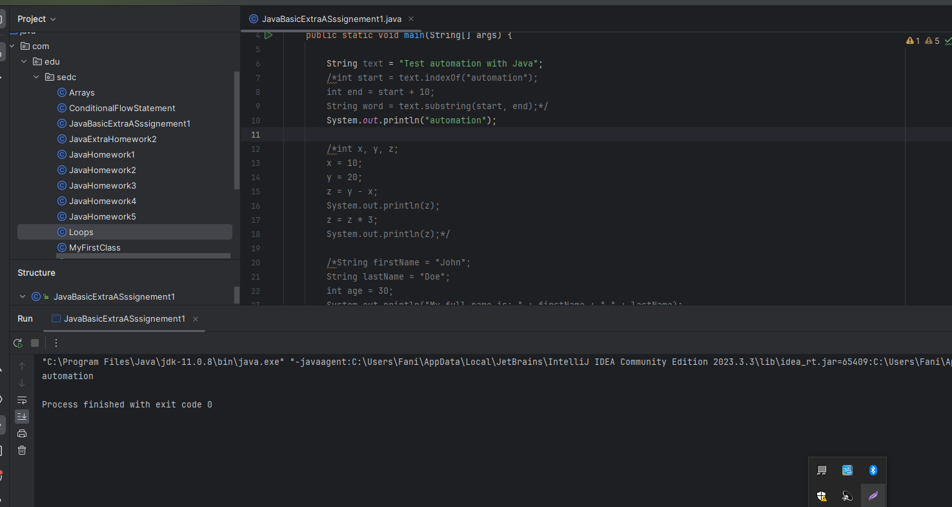

1. Declare 3 variables of type int x, y, z. Assign a value of 10 to x, 20 to y, and the value of z will be the subtraction between y and x. Print the result of z.

After printing the result, multiply the result of z by 3 and print it again.

int x, y, z;  
x = 10;  
y = 20;  
z = y - x;  
System.*out*.println(z);  
z = z * 3;  
System.*out*.println(z);

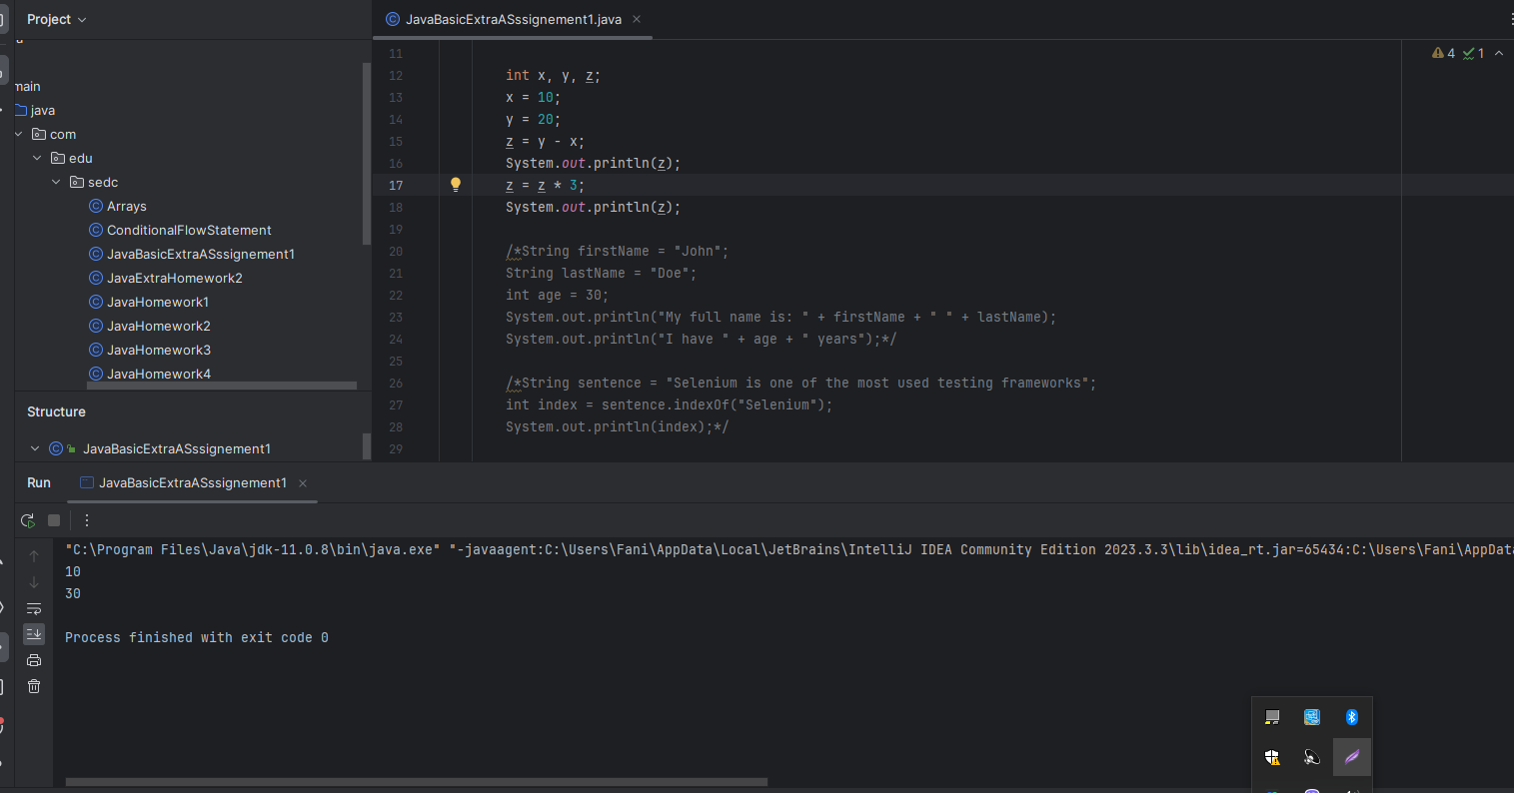

1. We want to print the following sentence in this format:   
   My full name is: John Doe

I have 30 years

John, Doe, and 30 should be stored in variables.

String firstName = "John";  
String lastName = "Doe";  
int age = 30;  
System.*out*.println("My full name is: " + firstName + " " + lastName);  
System.*out*.println("I have " + age + " years");

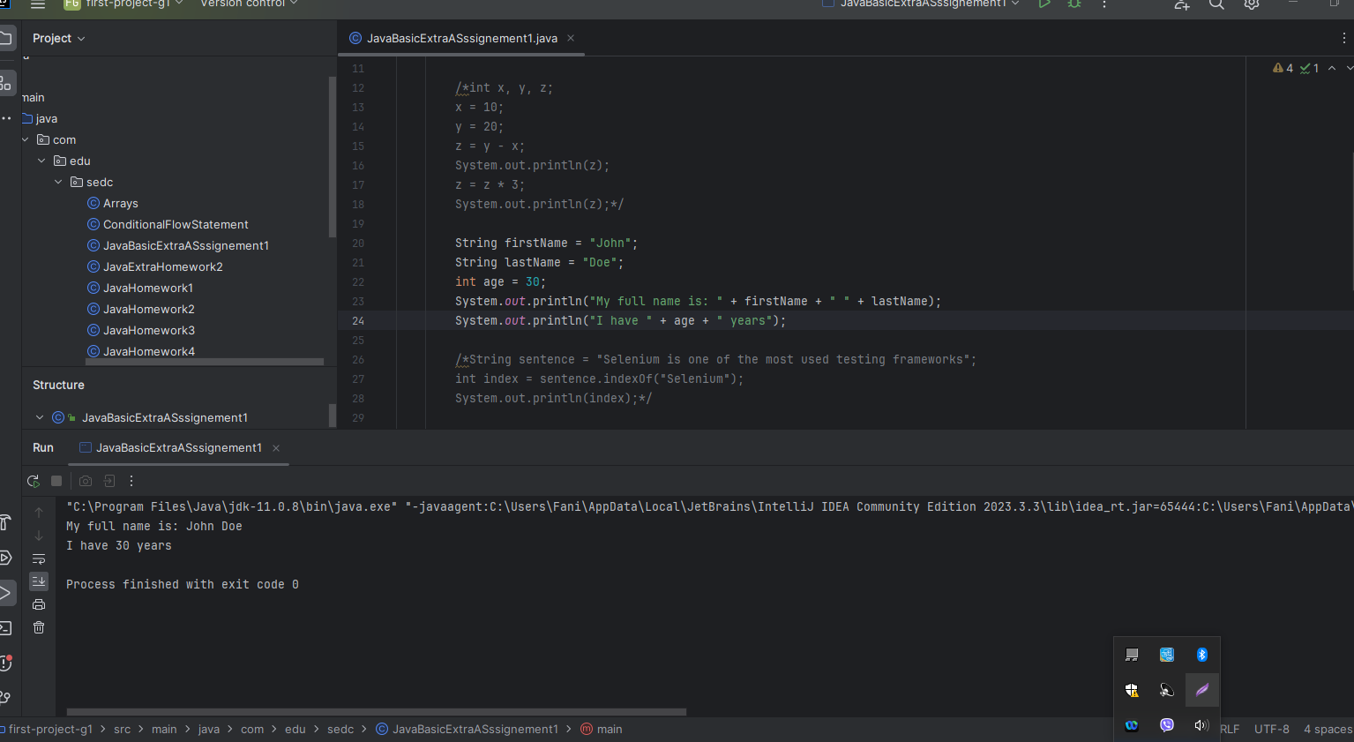

1. In the following sentence: "Selenium is one of the most used testing frameworks", print the index of the word Selenium.

String sentence = "Selenium is one of the most used testing frameworks";  
int index = sentence.indexOf("Selenium");   
System.*out*.println(index);

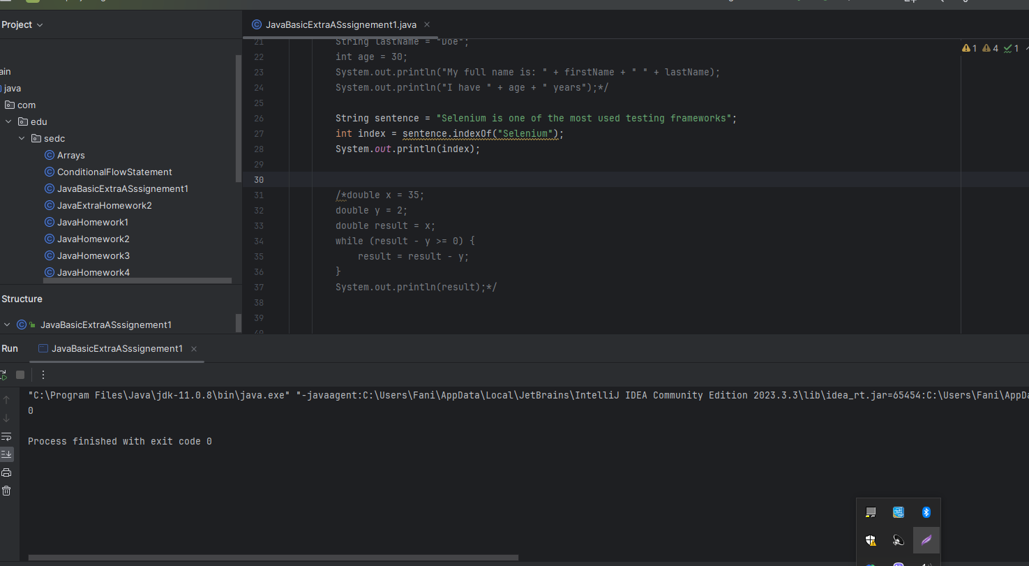

1. Initialize two variables x and y of type double with values 35 and 2.  
   Afterward, create a third variable of type integer that will return the remainder of the variables x and y.  
   Print the result of the third variable.

double x = 35;  
double y = 2;  
double result = x;  
while (result - y >= 0) {  
 result = result - y;  
}  
System.*out*.println(result);

